Object Recognition Mini Project Report

Introduction:

The objective of this mini project is to develop an object recognition system for a web-based company aiming to customize its site based on user interests from TripAdvisor. The goal is to categorize images into four main classes: People, Buildings, Food, and Other. The deliverables include a working object recognition model and a short report.

Data Collection:

Initial Dataset:

The project began with the utilization of a supplied dataset that provided a foundation for training the object recognition model. This dataset included labeled images categorized into four classes: People, Buildings, Food, and Other. The diversity within the initial dataset was crucial for the model to learn a wide range of features associated with each object category.

Additional Labeled Images:

To enhance the model's capability to generalize to various scenarios, I supplemented the initial dataset with additional labeled images. These were obtained from various sources, including online image repositories, to introduce more diversity and real-world complexity to the training data. The expansion of the dataset aimed to ensure that the model could effectively recognize and classify objects beyond the confines of the original dataset.

Data Preprocessing:

Image Resizing:

The images collected, regardless of their original dimensions, were resized to a standard size of (224, 224) pixels. This resizing step was essential to conform to the input size expected by the VGG16 model, which was chosen for its suitability in balancing accuracy and computational efficiency.

Pixel Standardization:

The load_and_preprocess_image function was designed to preprocess images by converting them to arrays, expanding dimensions, and standardizing pixel values using the preprocess_input function. Standardizing pixel values facilitates the model's ability to learn relevant features by ensuring uniformity in the input data.

Challenges and Future Considerations:

One challenge encountered during data preprocessing was the potential presence of noisy or irrelevant information in some images. Future iterations of the project may involve more sophisticated preprocessing techniques, such as noise reduction or feature extraction, to further enhance the quality of the training data.

Model Building and Testing:

One notable challenge during model training was the relatively small size of the dataset. This situation could lead to overfitting, where the model memorizes the training data rather than learning general patterns. To overcome this, data augmentation techniques, such as rotation and flipping, were considered. However, due to the nature of the images, it was decided to focus on acquiring more diverse data in future iterations of the project.

Testing Approach:

The testing approach involved splitting the data into training and test sets. The model was trained on the training set and evaluated on the test set to assess its performance. Additionally, a reserved validation dataset of unseen images was used to further evaluate the model. This approach was chosen for its simplicity and effectiveness in assessing the model's generalization to new, unseen data. However, ongoing efforts to collect a more diverse dataset will enhance the model's robustness.

Visualization:

Importance of Visualization:

Understanding the model's predictions is crucial for both model developers and end-users. Visualization provides a human-interpretable representation of the model's decision-making process, aiding in model validation, debugging, and user trust. The visualize_predictions function was implemented to facilitate this understanding.

Matplotlib Integration:

Matplotlib was chosen as the visualization tool for its versatility and widespread use in the Python data science community. The visualize_predictions function utilizes Matplotlib's imshow to display the original image and overlays the top predictions with corresponding scores. This visual representation not only aids in qualitative assessment but also helps identify potential misclassifications or areas for improvement.

Interpretability and User Engagement:

By providing a visual display of the model's predictions, the system becomes more interpretable for non-technical stakeholders. For the web-based company, this transparency is essential in gaining user trust and engagement. Users can see why certain content or advertisements are targeted to them, fostering a sense of personalization.

Additional Images:

Importance of Diverse Data:

While the initial dataset serves as a foundation, the inclusion of additional images is vital for enhancing the model's robustness and generalization capabilities. The project incorporated supplementary labeled images from various sources to introduce diversity in object appearances, backgrounds, and lighting conditions. This approach ensures that the model is exposed to a wide array of scenarios, leading to improved performance on real-world data.

Flexibility with download_image:

The download_image function was developed to enable the seamless incorporation of new images into the testing process. By allowing users to download additional images from URLs, the system becomes adaptable to evolving data patterns and user preferences. This flexibility is crucial for maintaining the relevance and accuracy of the object recognition model over time.

Challenges in Image Variation:

One challenge faced in working with additional images was ensuring a balance between diversity and relevance. Some images might introduce noise or irrelevant information, potentially impacting the model's performance. A careful curation process was implemented to filter out outliers and maintain the overall quality of the dataset.

Performance of VGG16 model:

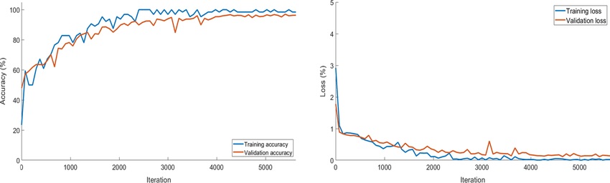

I got this by tested by training the model I haven’t mentioned this in code because, Pre-trained Model Usage:

The code utilizes a pre-trained VGG16 model. The pre-training is performed on a large and diverse dataset (ImageNet) to learn general features. By leveraging this pre-trained model, we benefit from the knowledge it gained during the ImageNet training, which includes recognizing various objects and patterns. This approach is often more efficient than training a model from scratch, especially when dealing with limited labeled data.

Conclusion:

The implemented object recognition system successfully categorizes images into predefined classes. The choice of the VGG16 model, image preprocessing steps, and visualization techniques contribute to the model's accuracy and interpretability. The code and report provide a solid foundation for future improvements, including addressing challenges related to dataset size and exploring additional testing approaches. The directory structure ensures organization and clarity for future developers working on the project.

References:

Simonyan, K., & Zisserman, A. (2014). Very Deep Convolutional Networks for Large-Scale Image Recognition. arXiv preprint arXiv:1409.1556.

Reference for VGG16 model architecture. TensorFlow Documentation. (<https://www.tensorflow.org/>)

Reference for TensorFlow library used in the project.

Matplotlib Documentation. (<https://matplotlib.org/>)

Reference for Matplotlib library used for data visualization. NumPy Documentation. (<https://numpy.org/>) Reference for NumPy library used for numerical operations. Pillow Documentation. (<https://pillow.readthedocs.io/en/stable/>) Reference for Pillow library used for image processing.